Swamp Meadow
Bringing
Community
Back to the
Theatre

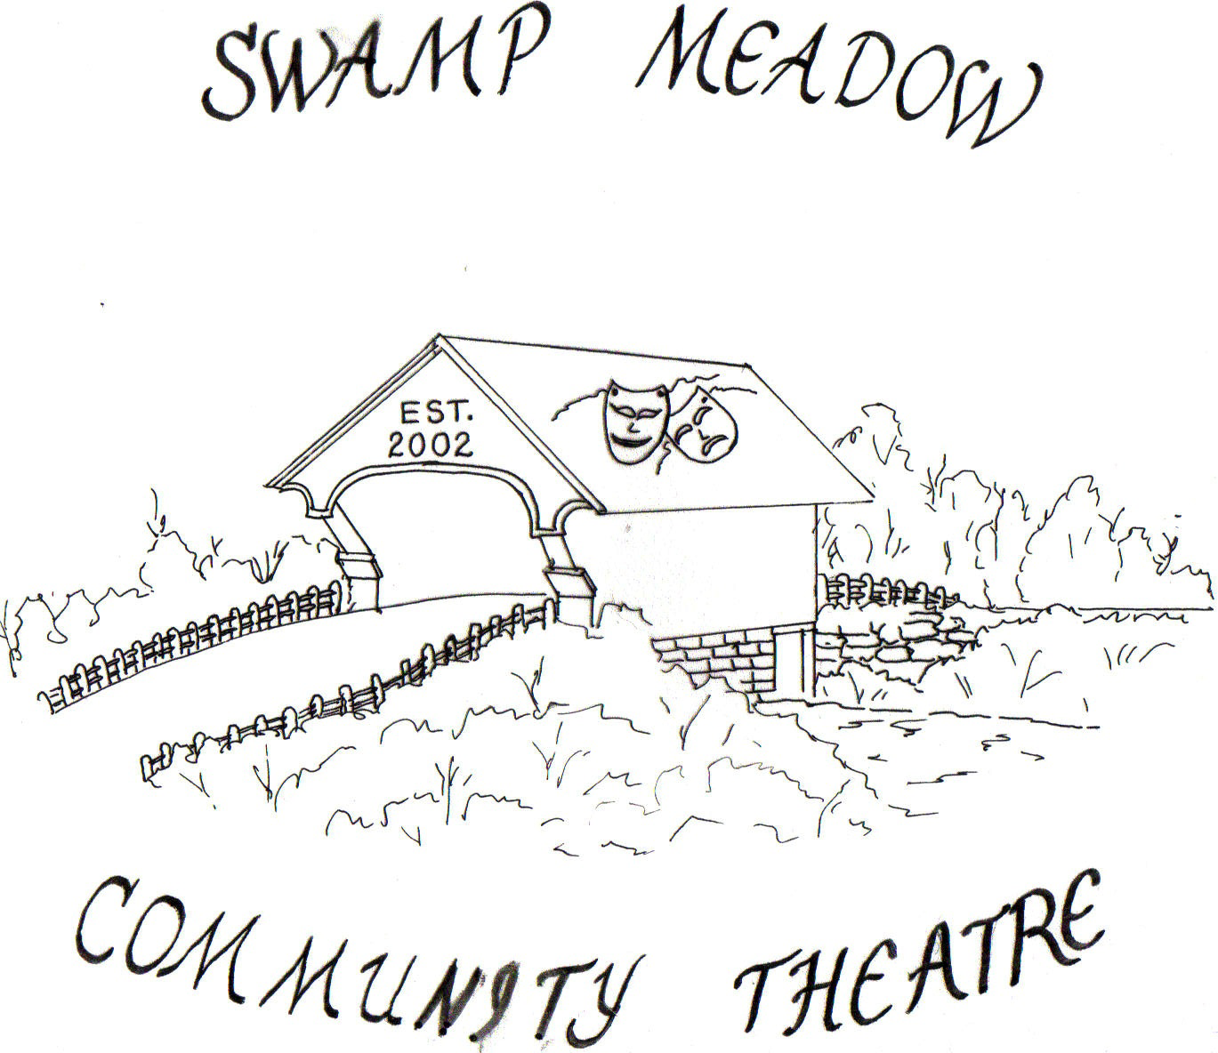

Community Service

Date: ______________

This is to acknowledge that __________________________________________

has satisfactorily completed _________ hours of community service at Swamp Meadow Community Theatre.

Signed: ____________________________
David Gresh
Box Office Coordinator

